SWINBURNE UNIVERSITY OF TECHNOLOGY
Hawthorn Campus
BACHELOR OF COMPUTER SCIENCE
Semester 1, 2025
COS30045 – Data Visualisation

____________________________________________________________
Project Stand Up 1
Visualising Drug Testing Enforcement in Australia: A State-by-State Analysis
Team Name: CL01_G21
Name – Yulan Yaneth Karunanayake
ID - 105107919

Table of Content
1. Introduction………………………………………………3
1.1. Background and Motivation……………………3
1.2. Visualisation purpose……………………………4
2. Data………………………………………………………5
2.1. Data Source and Governance………………….5
2.2. Data Processing and Analysis…………………10
2.3. Data Exploration………………………………12
3. Visualisation Design…………………………………..
3.1. Web Design……………………………………
3.2. Visualisation Design………………………
3.3. Interaction Design…………………………
4. Iteration and Validation……………………………
4.1. Testing and Refinements………………
4.2. Usability Evaluation………………………
5. Conclusion and Future Improvements………
6. References………………………………………………
7. Appendices……………………………………………
7.1. Gen AI Declaration………………………
7.2. Usability Evaluation Test Materials………
7.3. Notes/Data collected in Usability
Evaluation…………………………

- Introduction
  - Background and Motivation

Among the many users of this drug testing dashboard are law enforcement organizations, legislators, and members of the public, especially those who are worried about traffic safety and the dangers of driving while intoxicated. Legislators rely on high-level insights to evaluate the efficacy of present enforcement tactics, while police and enforcement agencies need precise data to pinpoint areas that need additional focus. Additionally, the public has a better understanding of the various drug testing procedures used by the states, which contributes to increased awareness and safer driving practices throughout Australia. Because drug-related accidents are on the rise, roadside drug tests are being used more frequently. The visualisation emphasises the need for easily accessible, trustworthy data that shows where tests are conducted and the results they provide.
This dashboard focuses on the increasing number of drivers who test positive for drugs while driving, which poses a serious risk to road safety. The dashboard gives stakeholders crucial information: the number of tests being performed, the percentage of positive findings, and how these numbers change over time between jurisdictions as the government responds by expanding roadside testing. Users can engage with the dashboard in order to:

- See how many roadside drug tests are performed annually or by state.
- Data can be filtered by detection technique, jurisdiction, and year.
- Examine the favorable outcome rates in various jurisdictions and years.
- Examine patterns in the number and results of drug tests.

  - Visualisation Purpose
This visualization's main goal is to give users the ability to investigate and assess the efficacy and uniformity of roadside drug testing throughout Australia. The dashboard is intended for a variety of users, each of whom interacts with the data in accordance with their own requirements. It can be used to track the number of tests carried out in different areas and spot possible reporting problems for law enforcement. Legislators can evaluate the effectiveness of the current drug testing systems and determine whether changes to the law or public awareness initiatives are required. The dashboard provides the general public with a useful tool for research or for spreading knowledge about initiatives to increase road safety. Through the integration of interactive features and a clear visual style, the dashboard converts raw data into a visually accessible format that is easy to comprehend.

- In altogether, how many drug tests are performed in each state each year?
- In what percentage of these tests do the results come back positive?
- How have the numbers of drug tests and their results changed over time?
- What is the most prevalent stage at which positive test results are found?
To ensure that the dashboard stays relevant and serves a purpose, these questions are carefully crafted to meet the various demands of each user group. Users may effectively explore enormous datasets and extract valuable insights because to its user-friendly design and extensive filter choices, which include state, year, test type, and detection method. This degree of personalization not only improves usability but also helps professionals make well-informed decisions and increases public awareness.

2. Data
2.1. Data Source and Governance
The Road Safety Enforcement Data Dictionary from the Australian Government's Department of Infrastructure, Transport, Regional Development, Communications, and the Arts serves as the data source for this drug test dashboard visualization. Police from various states, including the following, gathered this dataset:
- NSW Police force
- Victoria Police
- Queensland Police Service
- South Australia Police Force
- Western Australia Police Force
- Tasmania Police
- Northern Territory Police Force
- Australian Federal Police
The drug tests dashboard is primarily focused on the enforcement of roadside drug tests around Australia. It shows, according to the chosen year, the total number of drug tests performed, the proportion of positive findings, and the number of fines, arrests, and charges brought. To examine the data more thoroughly, users can filter it by year, testing stage, and jurisdiction.
The following testing phases are part of the 2023 dataset:

- Roadside testing (Indicator)
- Secondary confirmatory
- Not applicable
Among the 471,217 drug tests performed in 2023, 11.4% had positive findings. For that year, the visualization also shows 28,716 charges, 210 arrests, and 12,784 penalties. The dataset is updated frequently; the most recent change was made on February 21, 2025.
Age group, substance type, detection method, remoteness areas, and monthly-level detail are among the new data categories that were added in 2023. The Australian BITRE incorporates all three testing steps as of 2023, despite the fact that none of them were previously documented in previous datasets. The analysis only considers records that have BEST_DETECTION_METHOD = "Yes" in order to preserve data accuracy and prevent duplication (because a single test may span numerous phases).

Attribute (2023) | Description
Complete drug test | 471,217
Drug test result that is positive | 11.4%
Fines issued | 13,784
Charges | 28,716
Arrests | 210
Testing stages | Indicator, Laboratory, Not applicable
Filters | Jurisdiction, Year, Testing stage
Drug test conducted and result  overtime | From 2008 to 2023 with steady  increase
Tests per 10,000 licences | Highest in SA (392), lowest in ACT (31)
Update frequency | Annually

Data Collection Process
This dashboard's dataset is created using police enforcement records that have been supplied by different states and territories. Jurisdictions have been obliged since 2023 to incorporate more specific fields in their submissions, like testing sites and methodologies, in order to enhance the completeness and accuracy of the data. Oral fluid samples taken at the roadside provide the majority of the data used in drug tests. Up to three testing phases are frequently applied to these samples. Data on the overall number of drug tests performed, the proportion of positive findings, and enforcement outcomes—such as charges, penalties, and arrests—are reported by each jurisdiction.
Data Quality Assessment
Many jurisdictions offered comprehensive datasets, but some did not because of gaps or discrepancies in the data. Due to quality concerns, the Northern Territory, for instance, did not submit data on the total number of drug tests, positive findings, arrests, or charges in 2023; instead, they only reported the amount of penalties that were imposed. Likewise, governments such as Victoria and Tasmania excluded enforcement measures like fines, arrests, or prosecutions and merely disclosed the quantity of drug tests performed and the proportion of positive results. On the other hand, New South Wales provided a dataset that was largely comprehensive, albeit it was devoid of arrest data. Similar to this, Queensland provided the majority of the information, with the exception of arrest and fine numbers.
Security, Privacy and Ethical Considerations
Jurisdiction, location, age group, year, start and end dates, detection method, types of substances found, and enforcement results, such as charges, arrests, and penalties, are among the fields included in the Positive Drug Tests dataset, which is sourced from the Road Safety Enforcement Data. However, as the data is fully aggregated (by year, state, "All ages," and "All regions"), no private or sensitive information is included, including names, test sites, or license numbers. (https://www.bitre.gov.au/publications/2024/road-safety-enforcement-data)
Individual privacy is not jeopardized by the dataset, despite the fact that it contains comprehensive insights such as drugs discovered and the corresponding findings. To guarantee that all data is de-identified, broad labels like "All regions" and "All ages" are used in conjunction with binary indicators for drug detection techniques (Yes/No). Both ethical data handling and open public reporting are supported by this framework.
The dataset's primary privacy protections:
- Data is combined and made anonymous.
- There is no identifiable or personal information contained.
- Accessible to the general public without violating the privacy of those being tested

How The Data Supports the Visualization Purpose from section 1.2

The main topics listed in section 1.2 are directly supported by the dataset, which provides a clear and organized foundation. It contains crucial information including year, jurisdiction, testing stage, and the quantity of positive outcomes, allowing users to investigate important insights such:
- How many drug tests are performed in various states each year?
Although a few states give complete testing data, others only supply partial data, which can make cross-state comparisons less reliable.

- To what extent do tests yield positive results?
Test volume and positive result rates are frequently correlated. However, in many jurisdictions, the trustworthiness of full comparisons is impacted by incomplete reporting.

- In what ways has drug testing changed over time?
The dataset provides a glimpse of trends over time and covers the years 2008–2023. However, the clarity of the entire national picture is diminished by missing data from certain states or years.

- What is the stage of testing that produces the best results?
Just the data from 2023 makes a distinction between testing stages like "Indicator" and "Laboratory." Comparing stages is still only partially possible because not all jurisdictions offered this degree of data.

To sum up, the dataset facilitates the investigation of patterns in roadside drug testing throughout Australia. However, one should exercise caution when interpreting the results because of the conflicting reporting from several jurisdictions.

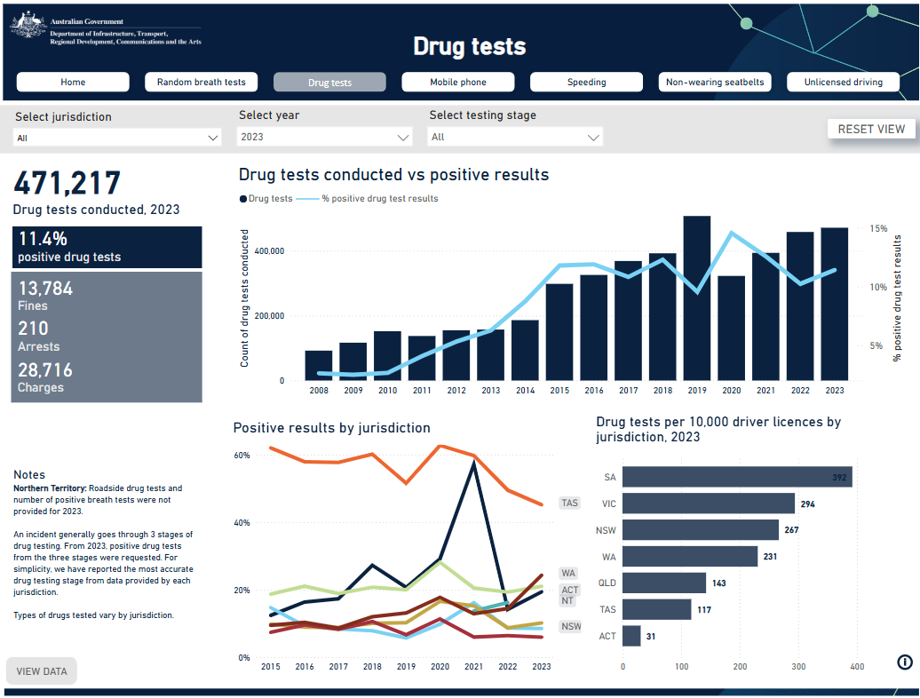

2. 2 Data Processing and analysis

For the purpose of analyzing trends in roadside drug testing throughout Australia, the dataset includes a number of essential features. These contain jurisdictional data, enforcement results, detection techniques, time-related fields, and drug types found. They are appropriate for a variety of visualisations, filters, and computed metrics because their properties are applicable to category, ordinal, and quantitative data types. These variables needed to be properly categorized, preprocessed, and transformed in order to guarantee useful analysis over time and across states.

Attribute | Description | Data type
YEAR | The drug test's recording year | Ordinal
START_DATE,  END_DATE | The data's temporal range | Interval (Date)
JURISDICTION | The territory or state in which the exam was conducted | Categorical
LOCATION | Test's general region (all areas, for example) | Categorical
AGE_GROUP | Age range (for example, all ages, 17–25) | Ordinal
METRIC | The kind of measurement (positive_drug_tests, for example) | Categorical
BEST_DETECTION_ME  THOD | shows whether this is the most precise detecting technique. | Categorical (Yes/No)
DETECTION_METHOD | Phase of detection (Laboratory, Indicator, etc.) | Categorical
AMPHETAMINE,  CANNABIS, COCAINE | types of substances examined for | Categorical (Yes/No)
NO_DRUGS_DETECTE  D | Was the outcome unfavorable? | Categorical (Yes/No)
COUNT | Count of drug tests that came out positive | Ratio (Quantitative)
FINES, ARRESTS,  CHARGES | The quantity of corresponding enforcement results | Ratio (Quantitative)

KNIME was used to process and analyze the data to make sure it was clear, consistent, and prepared for visualization. The following important fields were recognized and categorized based on their data types: FINES, ARRESTS, CHARGES, YEAR, JURISDICTION, COUNT, BEST_DETECTION_METHOD, and DETECTION_METHOD. In order to prevent counting the same test more than once in successive stages, the dataset was filtered to only contain entries with BEST_DETECTION_METHOD set to "Yes."
For enforcement results in jurisdictions with missing data, missing values were addressed by either creating proxy totals using accessible variables or eliminating incomplete records from particular visualisations. To facilitate more transparent trend comparisons, further computed parameters were developed, including Year, Month formats and test rates per 10,000 licensed drivers. Consistent naming conventions for testing stages and jurisdictions were also ensured by applying data standardization techniques.

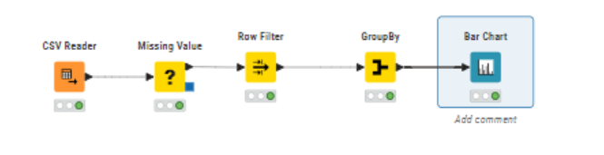

2.3 Data Exploration
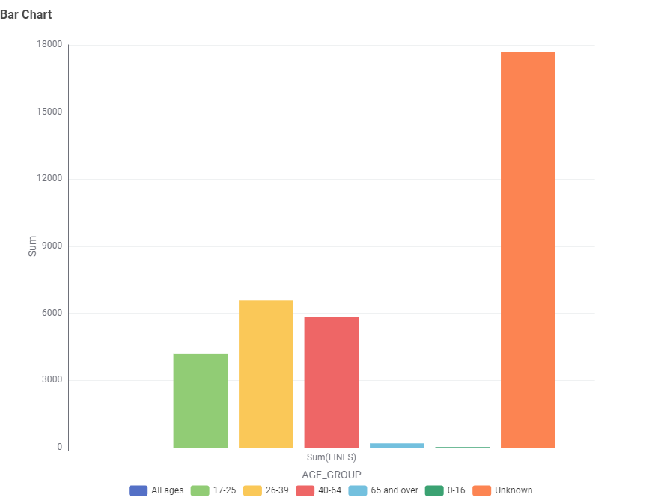
Illustration 0.0. The age groups 26–39 and 40–64 received the most fines, according to the bar chart, while the "Unknown" age group received the most.

- Drug test enforcement statistics from six countries in 2023 are compared in the table. New South Wales (NSW) had 40,551 drug tests, more than any other state. Queensland had 11,983 tests. With the highest number of fines (13,005) and charges (27,546), NSW also demonstrated a strong enforcement approach. However, because the Northern Territory and Tasmania did not provide comprehensive data for a number of enforcement outcomes, cross-state comparisons should be done with caution. Interestingly, South Australia registered a very high number of arrests (152), although conducting only 5,329 tests, indicating a clear operational focus or testing methodology.

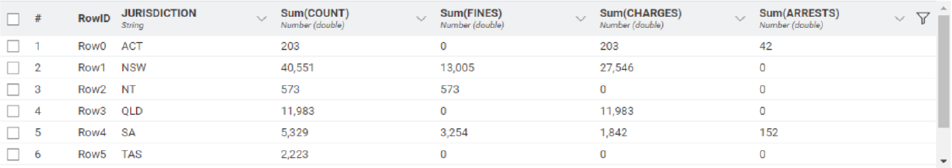

- This table presents the 2023 test results for the ACT and NSW by age group and location type (e.g., "Major Cities," "Inner Regional"). The age groups of 26–39 and 40–64 years old had 83 and 73 tests, respectively, in the ACT, indicating moderate levels of testing and charges as well as comparatively higher arrest rates. The 17–25 age group had a remarkably high number of tests (3,390) in NSW's Inner Regional districts, and there were also notable enforcement outcomes (1,584 fines and 1,806 charges). This suggests that younger drivers may be more frequently targeted for testing or may be having higher positive test results in regional areas.

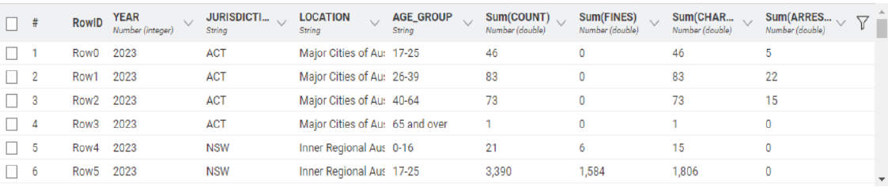
- Although the Exploratory Data Analysis (EDA) produced insightful findings, a number of difficulties were faced. These included incomplete enforcement outcome data from places like the Northern Territory, inconsistent reporting of testing stages, and an absence of geographic detail in previous datasets. A thorough examination of multi-phase testing methods was also limited because not all states provided results that were verified by laboratories. Notwithstanding these drawbacks, the analysis was successful in identifying significant enforcement hotspots, noteworthy demographic trends, and operational approach variations. These findings will all be taken into consideration when designing the dashboard and will help law enforcement agencies and policymakers make better decisions.

